

**EPAM Training Center**

**DWH**

**Tasks 6**

**Report**

**Minsk, 2017**

Revision history

|  |  |  |  |
| --- | --- | --- | --- |
| **Date** | **Version** | **Description** | **Author** |
| 08.11.2017 | 0.1 | Description of workflow (Tasks 6) | Olga Hilko |
|  |  |  |  |

Contests

Introduction 4

Purpose 4

1 Business Model 4

1.1 Business Process Description 4

1.2 Grain 4

1.3 Dimensions 4

1.4 Fact 4

2 Star scheme 5

2.1 SQL code 5

3 Snowflake sheme 7

# Introduction

## Purpose

This document includes the results of completed task 6.

# Business Model

## Business Process Description

In order to identify the business process

The present logic data model describes the process of making orders and holding payments for the goods. The main data describe the sales with their details by stores in different contexts.

It is useful to notice several peculiarities of the present logical model:

* Only entity Payment has a numeric measurement (amount),
* There is no currency codes and other countable values in spite of amount in Payment entity,
* All entities have update_date attribute,
* All entities are divided into logical groups (Products, Customer data, Geo data, Business).

So, in order to the top description we have data on warehouse-shop. One order (Sale) can be made by one Customer and served by an Employee, but payed in several steps (Payments) by the same or another Customer. Besides this the Payment can be taken by the Stuff, which differs from the Employee, who severed the order. In one Order only one Product can present. The order (Sale) is made in one Store.

## Grain

The grain of the business process is Payment event, which deals with the Order (Sale). We have 1:M relation between Sales and Payments, so Payments have the less granularity. Moreover, only Payment has a numeric measurement (amount), Sales do not have anyone. So our grain describes an atomic fact of Payment-event.

## Dimensions

This Payment-event is described in different contexts (linked with Customers, Products, Stores, Stuff or Employees) in time. Geo data is not a specific characteristic of the Sale, it is linked with Customers, Stores and Employees.

So we have the next dimensions (for attributes – see the code description in the paragraph 2.1):

* Customers (with their Address, but not in detailed form),
* Products (with Categories),
* Stores (identified the stores, their Manager’s info and their detailed Location: Address, City, Country, Region, EconRegion),
* Employees (describes Employees and Staff, includes their addresses),
* Date (each dimension has date-field, but they do not link with the DimDate, only Sales_date references to this dimension).

## Fact

There is no currency codes and other countable values in spite of **amount** in Payment entity. That is why it was taken as a measurement.

Moreover, it illustrates the main fact of payment for some amount on the Product.

The fact is characterized by:

Customer_id_sales – person who made the order,

Customer_id_payment – person who payed for the order,

Employee_id – stuff who server the order,

Staff_id – stuff who took the payment,

Sales_date_id – date of the order was made,

Product_id – ordered product,

Store_id – store where the order was made,

***Amount*** – the payed quantity of the product,

Update_dt – served attribute, which illustrates when last changes in the database record were made.

# Star scheme

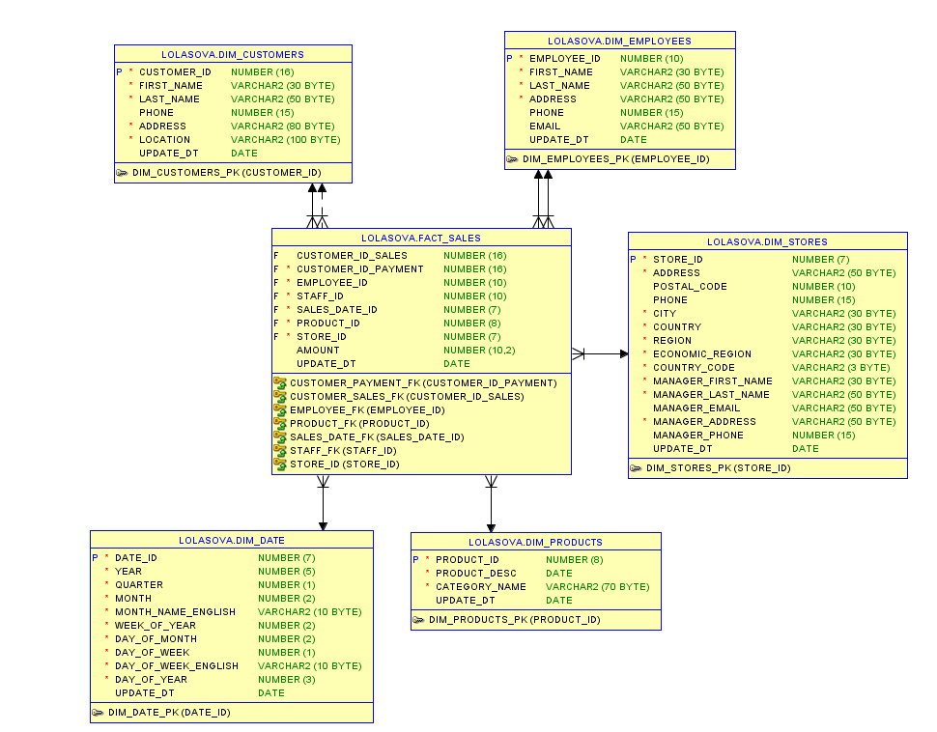

## SQL code

CREATE TABLE Dim_Products (

Product_id NUMBER(8) PRIMARY KEY,

Product_desc DATE NOT NULL,

Category_name VARCHAR2(70) NOT NULL,

Update_dt DATE

);

CREATE TABLE Dim_Customers (

Customer_id NUMBER(16) PRIMARY KEY,

First_name VARCHAR2(30) NOT NULL,

Last_name VARCHAR2(50) NOT NULL,

Phone NUMBER(15),

Address VARCHAR2(80) NOT NULL,

Location VARCHAR2(100) NOT NULL,

Update_dt DATE

);

CREATE TABLE Dim_Stores (

Store_id NUMBER(7) PRIMARY KEY,

Address VARCHAR2(50) NOT NULL,

Postal_code NUMBER(10),

Phone NUMBER(15),

City VARCHAR2(30) NOT NULL,

Country VARCHAR2(30) NOT NULL,

Region VARCHAR2(30) NOT NULL,

Economic_region VARCHAR2(30) NOT NULL,

Country_code VARCHAR2(3) NOT NULL,

Manager_first_name VARCHAR2(30) NOT NULL,

Manager_last_name VARCHAR2(50) NOT NULL,

Manager_email VARCHAR2(50),

Manager_Address VARCHAR2(50) NOT NULL,

Manager_phone NUMBER(15),

Update_dt DATE

);

CREATE TABLE Dim_Employees (

Employee_id NUMBER(10) PRIMARY KEY,

First_name VARCHAR2(30) NOT NULL,

Last_name VARCHAR2(50) NOT NULL,

Address VARCHAR2(50) NOT NULL,

Phone NUMBER(15),

Email VARCHAR2(50),

Update_dt DATE

);

CREATE TABLE Dim_Date (

Date_id NUMBER(7) PRIMARY KEY,

Year NUMBER(5) NOT NULL,

Quarter NUMBER(1) NOT NULL,

Month NUMBER(2) NOT NULL,

Month_name_English VARCHAR(10) NOT NULL,

Week_of_year NUMBER(2) NOT NULL,

Day_of_month NUMBER(2) NOT NULL,

Day_of_week NUMBER(1) NOT NULL,

Day_of_week_English VARCHAR2(10) NOT NULL,

Day_of_year NUMBER(3) NOT NULL,

Update_dt DATE

);

CREATE TABLE **Fact_Sales** (

Customer_id_sales NUMBER(16),

Customer_id_payment NUMBER(16) NOT NULL,

Employee_id NUMBER(10) NOT NULL,

Staff_id NUMBER(10) NOT NULL,

Sales_date_id NUMBER(7) NOT NULL,

Product_id NUMBER(8) NOT NULL,

Store_id NUMBER(7) NOT NULL,

Amount NUMBER(10,2),

Update_dt DATE,

CONSTRAINT customer_sales_fk FOREIGN KEY (Customer_id_sales) REFERENCES Dim_Customers(Customer_id),

CONSTRAINT customer_payment_fk FOREIGN KEY (Customer_id_payment) REFERENCES Dim_Customers(Customer_id),

CONSTRAINT employee_fk FOREIGN KEY (Employee_id) REFERENCES Dim_Employees(Employee_id),

CONSTRAINT staff_fk FOREIGN KEY (staff_id) REFERENCES Dim_Employees(Employee_id),

CONSTRAINT sales_date_fk FOREIGN KEY (sales_date_id) REFERENCES Dim_Date(Date_id),

CONSTRAINT product_fk FOREIGN KEY (product_id) REFERENCES Dim_Products(Product_id),

CONSTRAINT store_id FOREIGN KEY (store_id) REFERENCES Dim_Stores(Store_id)

);

# Snowflake sheme

In the snowflake model some dimensions are divided into several tables to be closer to the 3rd NF.

**Products** dimension is divided to the Products itself and its Categories.

**Customers** dimension is divided to Customer information and their proper Location (City, Country, Region, EconRegion) to have the opportunity to make filters and grouping on the Sales by their place of residence.

**Date** dimension is left as it was.

**Employees** dimension is a little be modified, too. We are not interested in the Location information of the Stuff during Sales analysis. Moreover this information is not mandatory and the attribute is big enough. That is why address is taken in a separate dimension (1:1 with the Employees).

**Stores** dimension has a proper detailing by Address (has telephone, address in the City, postal code), City, Country, Region, and EconRegion.

As it was in the star scheme each snowflake dimension has served date-update attribute.

